**AI SEO tools**

### **1. Jasper AI**

[Jasper AI](https://www.jasper.ai/) is an AI tool that can be used for SEO purposes. It assists marketers in creating high-quality, targeted content and optimizing it for search engine rankings. [You can use Jasper AI](https://www.demandsage.com/jasper-ai-free-trial/) to create branded content that aligns with your brand voice, and you can teach Jasper about your company and optimize your content accordingly.

**Best for:**

Jasper is a great tool for all business types, from individual, small to enterprise teams. If you are looking for AI SEO tools with the power to generate content as per your business's [brand's voice](https://www.mailmodo.com/guides/brand-voice/), Jasper might be it for you.

**Pricing:**

Free trial: ✅

Jasper AI offers three plans: creator, team, and custom so that you can invest according to your need. The creator plan is $49 per month. However, you can get it for $39 if you pay yearly. Check all the [plans and pricing](https://www.jasper.ai/pricing) here.

### **2. Frase**

[Frase](https://www.frase.io/) is one of the best AI SEO tools that offer content creation for bloggers, content creators, and marketers to streamline their content creation process and optimize it for SEO. With Frase, you can conduct research, generate well-written content, and refine it to maximize its impact. This all-in-one tool enables users to save time while ensuring high-quality output.

**Best for:**

Frase is one of the most popular AI copywriting tools. It is great for writing blogs and SEO content and helps you analyze the content. In short, a dream tool for content marketers.

**Pricing:**

Free trial: ❌

There is no free trial. However, you can get a 5-day product trial for $1.

Frase comes with different plans as per your requirement. The solo plan starts at $14.99 per month, and if you choose to pay yearly, you can get it for $12 per month. Check out the [pricing](https://www.frase.io/pricing) here.

### **3 Alli AI**

[Alli AI](https://www.alliai.com/) is one of the best no-code SEO tools that will help you scale and automate your SEO efforts, saving your team time, money, and energy. You can manage all your SEO tasks from one dashboard. You can optimize your website for SEO in minutes with this tool. Moreover, you can choose a business type and set up your workflow accordingly. It's a no-code solution to your SEO needs.

**Best for:**

Alli AI is an AI SEO tool for agencies, businesses, companies of all sizes, bloggers, and anyone with a website that needs to be optimized. It might be a costlier option for individuals or small teams.

**Pricing:**

Free trial: ✅

You can try out Alli AI for 10 days free. However, you need to fulfill credit card requirements. It has different plans for different business types. For starters, they have a consultant plan which costs $249 per month. You can check out all the [plans](https://www.alliai.com/pricing) here,

### **4. Market Brew**

[MarketBrew](https://marketbrew.ai/) is an AI SEO tool that can unit test your optimizations and provide insightful data in real-time, which might be impossible to get done manually. It can process and manage and analyze large amounts of data. It acts like a search engine and is user-friendly and easy to navigate. With its SEO testing feature, you can forecast SEO processes and A/B test every SEO change.

**Best for:**

MarketBrew is a great tool for agencies and businesses of all sizes wanting to get meaningful and actionable insights for their SEO efforts. It is not very suitable for individuals and content creators.

**Pricing:**

Free trial: ❌

Marketbrew does not provide a free plan. However, they provide a personalized demo, case studies, and references to go through. The pricing per search engine model is $400. Check the [pricing](https://marketbrew.ai/market-brew-license-pricing-options#brands) here.

**💡 Related guide:** [A Deep-Dive Into Best Practices of AI in Content Marketing](https://www.mailmodo.com/guides/ai-in-content-marketing/)

### **5 SEO AI**

[SEO AI](https://seo.ai/) provides content generation and optimization specifically tailored for search engine optimization (SEO). It utilizes proprietary algorithms and Google SERP analysis to produce high-quality SEO content that uncovers valuable keywords and helps boost organic traffic to your website. With this tool, you can also create long-form content that will help you rank higher on the search engine.

**Best for:**

SEO AI is an all-in-one tool for bloggers, content creators, small businesses, or anyone wanting to optimize and get their website to rank.

**Pricing:**

Free trial: ✅

SEO AI provides a 7-day free trial, giving you limited access to the tool. If you want to upgrade to a paid plan, the basic plan costs $49 per month, and the plus plan with more features costs $99.

### **6. ALPS AI**

[ALPS AI](https://www.alps.ai/) combines all SEO aspects in one place, eliminating the need to deploy multiple tools and analyze numerous variables. It offers a range of features and tools designed to help businesses improve their SEO performance and drive organic traffic.

**Best for:**

ALPS AI is a great tool for enterprises wanting to scale their SEO performance. It is an enterprise-specific SEO platform.

**Pricing:**

Free trial: ❌

ALPS does not provide a free plan or trial. However, you can [request a demo](https://www.alps.ai/request-demo/) designed specifically for you here.

### **7. Right Blogger**

[Right Blogger](https://rightblogger.com/) is an AI SEO tool with 40+ AI-powered tools like keyword research, content creation, ideas, keyword cluster, Meta titles, description writing, etc. It helps you curate your content per SEO guidelines and helps you rank higher.

**Best for:**

Right Blogger, just like its name, is a great AI SEO tool for bloggers and content creators wanting to speed up their content creation process. This tool will provide an AI assistant from the website to social media.

**Pricing:**

Free trial: ❌

Right Blogger has an unlimited plan with all 40+ AI-powered tools, costing $29.99 per month.

### **8 Keyword Insights**

[Keyword Insights](https://www.keywordinsights.ai/) is an AI SEO tool that helps you research, plan and outline keywords. It lets you generate thousands of keyword ideas, makes clusters, and creates detailed content effortlessly. You can group the keywords with the same intent and quickly identify the search intent behind keywords at scale.

**Best for:**

Keyword Insights is a great tool for content marketers, SEO managers, and freelancers to research the best keywords for their content to rank.

**Pricing:**

Keyword Insights does not have a free trial. You can try the tool with 750 credits (750 keywords and more) for $1. The basic paid plan starts at $49. Check out the [full pricing plan](https://www.keywordinsights.ai/pricing/) here.

### **9. Twinword**

[Twinword](https://www.twinword.com/ideas/) is an AI SEO tool designed for keyword research, grouping, and providing relevant and accurate keyword data. It provides you with a comprehensive dashboard for every keyword you search for. You can search user intent, keyword patterns, search volume, keyword score, SEO competition, CPC, word count, and more.

**Best for:**

Twinword is a great tool for all, including SEO managers, teams handling website optimizations, content marketers, bloggers, freelance writers, etc.

**Pricing:**

Free plan: ✅

Twinword lets you use the tool for free with limited searches. Upgrade to paid plans to increase the usage starting from $12. Check the [pricing](https://www.twinword.com/ideas/pricing/) here.

### **10. OutRanking**

[OutRanking](https://www.outranking.io/) is an SEO AI tool that helps you optimize and automate content by leveraging AI. It offers an AI-assisted workflow for SEO content writing, making it easier to dominate search engine rankings. With features like the AI Wizard, SERP analysis, and integration capabilities, Outranking streamlines content creation and helps businesses outrank their competitors.

**Best for:**

OutRanking is best for people wanting to outperform their competitors and rank higher on the search engine.

**Pricing:**

Free trial: ❌

OutRanking lets you use the tool for $7 for the first month. After that, the solo plan will cost you $69 per month. Check out other [plans](https://www.outranking.io/pricing-plan/) here.

### **11. Scalenut**

[Scalenut](https://www.scalenut.com/) is an AI co-pilot SEO tool that can help you automate and power up the whole SEO lifecycle. Scalenut provides various tools and generators for different purposes, including paragraph generation, Google Ads description generation, video description generation, and product description generation. It also offers a keyword planning feature that helps you with keyword research and clustering.

**Best for:**

This tool is best for content marketers and businesses wanting to scale their content creation process and get help with SEO strategies and activities.

**Pricing:**

Free plan: ✅

Scalenut provides a 7-day free trial. If you want to upgrade, you can try its essential plan costing $39 per month. You can get heavy discounts on plans if you pay yearly. Check out the [plans and pricing](https://www.scalenut.com/pricing) here.

### **12. MarketMuse**

[MarketMuse](https://www.marketmuse.com/) is an AI SEO tool that helps you analyze your website and gives you personalized and actionable insights so you never rely on generic data and opinions. You can make informed decisions and deliver data-driven on-page optimizations in lesser time and effort.

**Best for:**

MarketMuse is best for content managers and marketers responsible for delivering results, making informed decisions, and reporting to the stakeholders.

**Pricing:**

Free trial: ✅

You can use its standard plan for 7 days free. MarketMuse has a free plan that lets you use the tool with limited queries per month. If you want to upgrade to the standard plan, it will cost you $149 per month. Check the [pricing](https://www.marketmuse.com/pricing/) here.

### **13. Linkbot**

[Linkbot](https://www.linkbot.com/) is another very useful AI SEO tool that helps you with internal linking, which will, in turn, help you improve your website's SEO. It easily understands your website structure and automatically creates links based on the content. You can also visualize the links and content that drive engagement.

**Best for:**

This tool is best for content writers, SEO managers, and content marketers. This tool will help you internally link your website in the best possible way.

**Pricing:**

Free trial: ✅

Linkbot comes with a free plan with limited access and properties. The professional plan starts from $29 per month if you want to upgrade. You also get a 30-day free trial before you pay for professional and business plans. Check out the [pricing](https://www.linkbot.com/#pricing-3) here.

### **14. WriterZen**

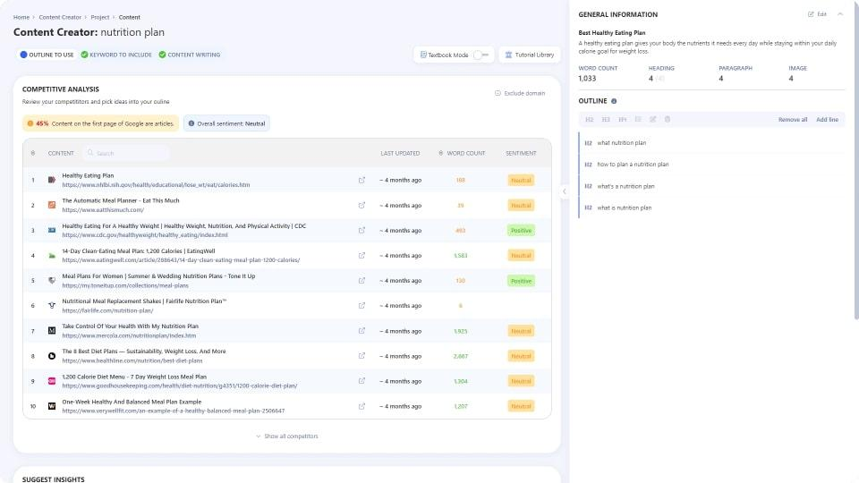

WriterZen is a workflow-centric website content creation platform optimized for search engine rankings. It includes modules for topic discovery, keyword ranking, and content editing, including AI text generation and plagiarism checking.

#### WriterZen best features

* Topic discovery tool creates topic clusters to help generate multiple linked pages
* Broad keyword research and recommendation tool, including keyword difficulty scores
* Content editor includes data on competitive sites
* Team collaboration tools

#### WriterZen limitations

* Keyword tool user interface can be cumbersome for some SEO strategies
* Content editor user interface is crowded and challenging for creating content ideas
* Missing some SEO tool features like link building and backlink checking
* Limited project management and collaboration tools to tag along with your SEO efforts

#### WriterZen pricing

* **Lite:**$23/month per user
* **Plus:**$89/month per user
* **Pro:**$219/month per user
* **Ultra:**$399/month per user

### **15. Byword**

### Byword

Byword is an [AI content generator](https://clickup.com/blog/ai-content-generator/) focused on SEO article creation. Users feed it target keywords and define a writing style, and the program does the rest. It uses natural language processing and machine learning algorithms to generate content.

#### Byword best features

* Built to generate informational articles that are optimized for search engine placement
* State-of-the-art algorithms bypass most AI detectors
* Supports nine languages
* Allows users to define a writing style
* Supports background process, generating multiple articles at the same time

#### Byword limitations

* Generating a short social media post costs as much as a long article
* No other tools for SEO beyond AI text generation
* Not a good solution for non-factual content
* No collaboration or project management tools

#### Byword pricing

Generating one story costs one credit.

* **Starter:**$99 for 25 credits/month
* **Standard:**$299 for 80 credits/month
* **Scale:**$999 for 300 credits/month
* **Unlimited:**$2,499 for unlimited credits

### **16. NitroPack**

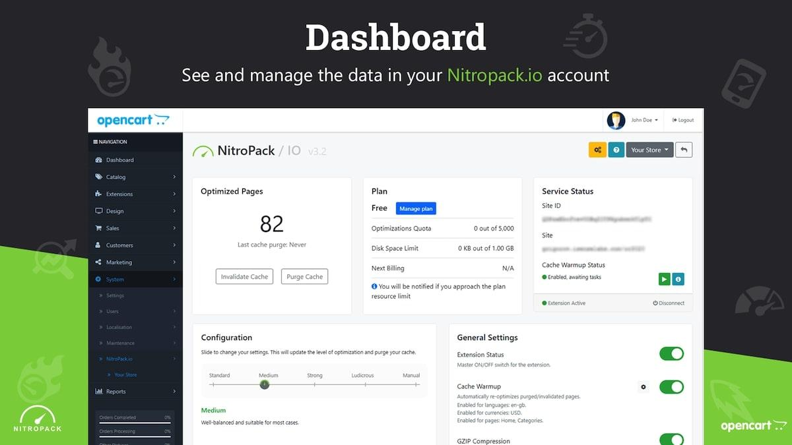

NitroPack improves a site’s search rankings by increasing the website’s speed. It includes an advanced caching mechanism and tools to accelerate the loading of images. It can also improve HTML, CSS, and JavaScript performance, and supports WordPress, OpenCart, WooCommerce, and Magento websites.

#### NitroPack best features

* Reduces page loading times to industry-leading speeds
* Comprehensive image optimization tools, including automatic conversion to WebP format
* Plugins make implementation simple
* Approaches speed optimization with multiple features

#### NitroPack limitations

* Only does webpage loading speedups, no other aspects of SEO
* Supports a limited number of web content management systems
* Incompatible with some plugins

#### NitroPack pricing

* **Business:**$21/month for one website
* **Growth:**$51/month for one website
* **Scale:**$176/month for one website
* **Custom:**Contact for pricing

#### NitroPack ratings and reviews

* **G2:**N/A
* **Capterra:**N/A